

# Form_purple

# Volunteer application form

Please fill in this form clearly. If you are interested in a specific opportunity please tell us which one here



If you would like support to fill in this form please speak to Sam Lamb

Please circle your answers and use the boxes to write in to tell us more.

Yes

Mr Mrs Ms Miss Date of birth

Other (like Dr)

First name

Last name



Post code

Address



Telephone number



Mobile



Email

How did you find out about volunteering for Bournemouth Gateway Club?

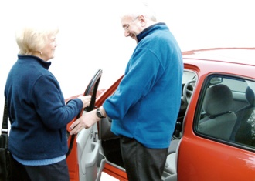

Have you done any voluntary work before?

Yes No

If your answer is yes, tell us more about what you have done.

Why do you want to volunteer with Bournemouth Gateway Club?

Have you got any experience to do with people with a learning disability?

Yes No

If yes, please tell us more



What skills do you have that you would like to use as a volunteer?



What things do you enjoy doing?

Is there anything you do **not** enjoy doing?

When can you volunteer? Tell us the days and times





Do you have a car that you could use when you are volunteering?

Yes No

Is there anything to do with your health that will stop you from doing some types of volunteering?

Yes No

If yes, please tell us more

We need the names and addresses of 2 people who can tell us what you would be like as a volunteer.

We will write to them and we might telephone them.

Choose people who are **not** in your family.

For example, you could choose your employer, a friend, your imam and so on.

**Person 1**

Name



Post code

Address



Telephone number



**Person 2**

Name



Post code

Address



Telephone number

**Confidential – private**

Bournemouth Gateway Club has to make sure all our volunteers are safe to work with people with a learning disability.



Have you ever been convicted of any criminal offence by a court of law?

Yes No

We will only take into account a criminal record if it could be important to the volunteering you want to do.

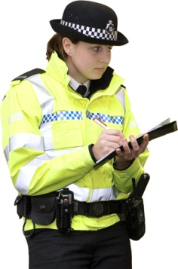All Bournemouth Gateway Club volunteers who spend time with people with a learning disability need to have a police check through the Criminal Records Bureau before they can start.

There is another (online) form you will be asked to fill in for the Criminal Records Bureau check if you are going to be a volunteer with Bournemouth Gateway Club.

**and finally…..**

**You now need to sign this form.**

Bournemouth Gateway Club will keep your information safe. We will use what you tell us to send you information about

* volunteering
* Mencap and what we do.



Please write your **name** in **box 1** then **sign** in **box 2**.

**All the information I have put in this form is true as far as I know.**

1

Name



2

Signed

Date



**Please bring this form in to club or send this form to**

Bournemouth Gateway

c/o 60 Leybourne Ave

Bournemouth

BH10 6HF

Telephone - 07872627301

Email – bournemouthgateway@hotmail.co.uk

Website – http://bournemouthgateway.btck.co.uk

Thanks to Photosymbols for the pictures in this form.